1. INTRODUCTION

  - OVERVIEW
The ultimate aim of developing the website “PAWSCARE” is to managing the overall vaccination of dogs. In a world where our pets are cherished family members, ensuring their well-being is paramount. PawsCare is a cutting-edge web platform designed to streamline anti-rabies vaccination management for dogs. By automating reminders and facilitating communication between pet owners and veterinary professionals. PawsCare aims to create healthier, happier canine companions. Join us on this digital journey toward responsible pet care.
1.2. PROBLEM DEFENITION
System analysis is the process of gathering data and facts diagnosing problem to the system. In the development of software structural analysis is required. During this analysis, information is collected in the form of answers to the question for collecting information from existing documents. Analysis specifies what the system should do.
Problem definition deals with defining the actual problem involved in the existing system or the system to be developed. Studies on various areas covered by the existing system are classified into various divisions and the actual task to be performed in the new system is determined. The project will be able to demonstrate the ideas of a website which helps the public. The website is trying to revitalize and simplify the various functions and activities and make them more people friendly. We dedicated to providing better speedy services to the public.
System analysis is the detailed study of various operations and their relationship within and outside the system. It is the first in the developing and managing systems. System analysis is concerned with becoming aware of the problem, identifying the relevant and most decisional variables, analyzing and synthesizing the various factors and determining an optimal or at least as at is factory solution on programmed of action. A preliminary study was conducted in details several fact-finding techniques like record searching, observation, comparison etc. were used to reach a better decision. The current system for this each activity was deeply studied and analyzed. All the forms and other printed or non-printed formats for data collection where checked accurately and findings were compared. Observation was done to graet extend to see the difficulties of the process and time delay in finding the results. Accurate study was conducted to know the system in a much better manner.
1.3. OBJECTIVE
The objectives of the system analysis are:
- Identifying he need.
- Analyzing the existing and proposed system
- Evaluating the feasibility study.

- Perform economic and technical analysis.
- Identifying the hardware and software requirements.
- Allocating functions to the hardware and software.
The three distant user’s roles
1.User
- User can register, book appointments.
- One user can register vaccination for multiple dogs.
- User can view the appointments that are granted by the hospital.
- User can request the hospital to reschedule the appointments.
- User can receive the
- notifications and alerts send by the hospital.
2. Admin
. DBA have the responsibilities including:
- Managing the database
- Securing the database
- Maintaining the database
- They authorize handle capacity planning installation and monitor usage.
- Admin can view complaints made by the user.
3. Hospital
- Hospital can access full details of the dogs.
- Hospital can view their own profile and can update it.
- They can send real-time alerts and notifications via SMS, email, and through the website.
- They can provide appointments to the users and view those appointments in the website.
- They can reschedule the appointments as per the needs of the user.

2. SYSTEM STUDY AND ANALYSIS

2.1. INTRODUCTION
In a world where our pets are cherished family members, ensuring their well-being is paramount. PawsCare is a cutting-edge web platform designed to streamline anti-rabies vaccination management for dogs. By automating reminders and facilitating communication between pet owners and veterinary professionals. PawsCare aims to create healthier, happier canine companions.
2.2 EXISTING SYSTEM
In the realm of innovative solutions, PawsCare stands out—a visionary platform that seamlessly manages anti-rabies vaccinations for our beloved dogs. Picture a world where pet owners receive personalized reminders via text messages and email, ensuring timely vaccinations. Imagine veterinary professionals effortlessly accessing appointment details and sending notifications.
2.2.1. Drawbacks
- . The main drawback of the existing system is that the documentation barriers.
- . There is a rush in the veterinary hospital and due to which there is loss of time.
2.3. PROPOSED SYSTEM
The proposed system “Paws Care” or PAWS CARE overcomes all the disadvantages of existing system by adding extra features. It is a visionary platform that simplifies canine anti-rabies vaccination management. Pet owners register their dogs, record vaccination dates, and receive automated reminders via text and email. Veterinary hospitals view vaccination status, schedule appointments, and send personalized notifications. While Paws Care is yet to exist, its promise of healthier dogs is our mission.
2.3.1. Advantages
- Operations are done in systematic way.
- Avoid documentation difficulties & other constraints in hospitals.
- Organization can access the complete details of the pets.
2.4. MODULE DESCRIPTION
1. Users
- User can register, book appointments.
- User can view the appointments that are granted by the hospital.
- One user can register vaccination for multiple dogs.

- User can request the hospital to reschedule the appointments.
- User can receive the notifications and alerts send by the hospital
2.Admin
- DBA have the responsibilities including:
    - Managing the database
    - Securing the database
    - Maintaining the database
- They authorize handle capacity planning installation and monitor usage.
- Admin can view complaints made by the user.
3.Hospital
- Hospital can access full details of the dogs.
- Hospital can view their own profile and can update it.
- They can send real-time alerts and notifications via SMS, email, and through the website.
- They can provide appointments to the users and view those appointments in the website.
- They can reschedule the appointments as per the needs of the user.

2.5. PROJECT PLAN
Planning is very important in every aspect of development work. Good managers carefully monitor developments at various phases. Improper planning leads to failure of the project. Software project plan can be viewed as the following:
- Within the organization: How the project is to be implemented? What are the various constraints? What is market strategy?
- With respect to the customer: Weekly or timely meetings with the customer with presentations on status reports. Customer feedback is also taken and further modifications and developments are done. Project milestones are deliverables are also presented to the customer.

For a successful project the following steps can be followed:
- Selection of project: Includes identifying project’s aims and objectives, understanding requirements and specification, methos of analysis, design and implementation, testing techniques and documentation.
- Project milestones are deliverables.
- Project estimates: including cost, time, size of code and duration
- Resource allocation: including hardware, software, previous relevant project information and digital library
- Risk management: including risk avoidance, risk detection, risk control and risk recovery
- Scheduling techniques: including work breakdown structure, activity graph, critical path method, Gantt chart and Program Evaluation Review Technique.
- People: including staff requirement, team management and customer interaction. Quality control and standard
2.6. FEASIBILITY STUDY
The initial investigation points to the question whether the project is feasible. The feasibility is conducted to identify the best system that meets all the requirements. This includes an identification description, an evaluation of proposed systems and the selection of the best system for the job. The requirements of the system are specified with a set of constraints such as system objectives and the description of the output. It is the duty of the analyst to evaluate the feasibility of the proposed system to generate the above results. Three key factors are to be considered during the feasibility study.
There are three aspects in the feasibility study portion of the preliminary investigation:
- Technical feasibility
- Economic Feasibility
- Operational feasibility
The proposed system "PAWSCARE" must be evaluated from the technical point of view first, and if technically feasible their impact on the organization must be assessed. If compatible, Technical Feasibility Economic Feasibility Operational system can be devised. Then they must be tested for economic feasibility.

2.6.1. Technical Feasibility
The "PAWSCARE" must be evaluated from the technical viewpoint. The assessment feasibility must be based on an outline design of the system requirement in the terms of input, output, programs, procedure and employee. Having identified an outline system, the investigation must go to suggest the type of the equipment, required method developing the system, method of running the system once it has been designed. The project should be developed such that the necessary functions and performance are achieved within the constraints. Though the system may become obsolete after some period of time, due to the fact that the newer version software supports the older version, this system may still be used.
There are a number of technical issues, which are generally raised during the feasibility stage of the investigation PAWSCARE. A study of function, performance and constraints that may affect the ability to achieve an acceptable system. Technical feasibility deals with hardware as well as software requirements. If the necessary requirements are made available with the system, then the proposed system is said to be technically feasible.
2.6.2. Economic Feasibility
Economic feasibility is an important task of system analysis. A system that can be developed technically and that will be used if installed must still be profitable for the organization. Financial benefits must equal or exceed the costs. Criteria are to ensure that effort taken on the project give the best return at the earliest. One of the factors, which affect the development of a new system, is the cost it would require. Since the system developed is part of a project work, there is no manual cost to spend for the "PAWSCARE". Also, all the resources are already available, giving an indication that the system is economically possible development. The analysis raises financial and economic questions during the preliminary investigation to estimate the following:
1. The cost to conduct a full systems investigation
2. The cost of hardware and software for the class of application of the project being considered.
3. The benefits in the form of reduced costs or fewer costly errors.
To be judged feasible, a proposal for the specific project must pass all these tests, otherwise it is not considered as a feasible project.

2.6.3. OPERATIONAL FEASIBILITY
Proposed projects are beneficial only if they can be turned into information systems that will meet the operating requirements of the organization. This test of feasibility tasks if the system will work when it is developed and installed. "PAWSCARE" satisfies all the operational conditions.
One of the main problems faced during development of a new system is getting the acceptance from the user. They were doubtful about the degree of security provided by our software. We have considered all the operational aspects. Thus, the project is operationally feasible. People are inherently resistant to change, and computers have been known to facilitate change. An estimate should be made about the reaction of the user, employee towards the development of a computerized system.

- REQUIREMENT ANALYSIS AND SPECIFICATION

3.1 INTRODUCTION

Requirement analysis results in the specification of software’s operational characteristics; indicates software’s interface with other system elements and establishes constraints the software must meet. Requirement analysis allows the software engineer to elaborate on basic requirements established during earlier requirement engineering tasks and build models that depict user scenarios, functional activities, problem classes and their relationships, system and class behavior and flow of data as it is transformed. Requirement analysis provides the software designer with representation of information, function and behavior that can be translated to architectural, interface and component level designs. Finally, the analysis model and the requirement specification provide the development and the customs with the means to access quality once the software is built. The main requirement of this project is to eliminate the communication gap between a person who wants to build a home and the people needed for the process.

3.2 SOFTWARE AND HARDWARE REPRESENTATION

3.2.1 Hardware Requirements

Microprocessor Types : inteli3 and above
Processor speed : 2.5 GHZ
Random Access Memory : 4 GB
Hard Disk Memory : 500 GB
Monitor : SVGA Color
Keyboard : Standard Keyboard
Mouse : Standard Scroll Mouse

3.2.2 Front End

Python is one of those rare languages which can claim to be both simple and powerful. It is easy to concentrate on the solution to the problem rather than the syntax and structure of the language you are programming in. Python is an easy to learn, powerful programming language. It has efficient high-level data structures and a simple but effective approach to object-oriented programming. Python's elegant syntax and dynamic typing, together with its interpreted nature, make it an ideal language for scripting and rapid application development in many areas on most platforms. Guido van Rossum, the creator of the Python language, named the language after the BBC show "Monty Python's Flying Circus". He doesn't particularly like snakes that kill animals for food by winding their long bodies around them and crushing them. Python is a simple and minimalistic language. Reading a Python program feels almost like reading English. This pseudo-code nature of Python is one of its greatest strengths. It allows you to concentrate on the solution to the problem rather than the language itself. Python is an example of a FLOSS (Free/Libre and Open-Source Software). In simple terms, you can freely distribute copies of this software, read its source code, make changes to it, and use pieces of it in new free programs. FLOSS is based on the concept of a community which shares knowledge. This is one of the reasons why Python is so good - it has been created and is constantly improved by a community who just want to see a

better Python. Due to its open-source nature, Python has been ported to (i.e. changed to make it work on) many platforms. All your Python programs can work on any of these platforms without requiring any changes at all if you are careful enough to avoid any system-dependent features.

A program written in a compiled language like C or C++ is converted from the source language i.e. C or C++ into a language that is spoken by your computer (binary code i.e. 0s and 1s) using a compiler with various flags and options. When you run the program, the linker/loader software copies the program from hard disk to memory and starts running it. Python, on the other hand, does not need compilation to binary. You just run the program directly from the source code. Internally, Python converts the source code into an intermediate form called byte codes and then translates this into the native language of your computer and then runs it. All this, actually, makes using Python much easier since you don't have to worry about compiling the program, making sure that the proper Pawscare 12 College of applied science perissery libraries are linked and loaded, etc. This also makes your Python programs much more portable, since you can just copy your Python program onto another computer and it just works! Python supports procedure-oriented programming as well as object-oriented programming. In procedure-oriented languages, the program is built around procedures or functions which are nothing but reusable pieces of programs. In object-oriented languages, the program is built around objects which combine data and functionality. Python has a very powerful but simplistic way of doing OOP, especially when compared to big languages like C++ or Java. Python is indeed an exciting and powerful language. It has the right combination of performance and features that make writing programs in Python both fun and easy.

PYTHON
Python is a dynamic, high level, free open source and Interpreted programming language. It supports object-oriented programming as well as procedural oriented programming. In Python, we don't need to declare the type of variable because it is a dynamic typed language. For example, x=10,here x can be anything such as String, int etc.
Features
There are many features in Python, some of which are discussed below-
1.Easy to Code:
Python is high level programming language. Python is very easy to learn language as compared to other language like c, c#, java script, java etc. It is very easy to code in python language and anybody can learn python basic in few hours or days. It is also developer friendly language.
2. Free and Open Source:
Python language is freely available at official website you can download it. Since, it is open source; this means that source code is also available to the public so you can download it as, used it well as share it.

3. Object-Oriented Language:
One of the key features of python is Object-Oriented programming. Python supports object-oriented language and concepts of classes, objects encapsulation etc.
4. GUI Programming Support:
Graphical Users interfaces can be made using a module such as PyQt5, PyQt4, python or Tk in python. PyQt5 is the most popular option for creating graphical apps with Python.
5. High-Level Language:
Python is a high-level language. When we write programs in python, we do not need to remember the system architecture, nor do we need to manage the memory.
6. Extensible feature:
Python is an Extensible language. We can write some python code into c or C++ language and also, we can compile that code in C/C++ language.
7. Python is Portable language:
Python language is also a portable language. For example, if we have python code for windows and if we want to run this code on other platform such as Linux, UNIX and Mac then we do not need to change it, we can run this code on any platform.
8.Python is integrated language:
Python is also an integrated language because we can easily integrated python with other language like C, C++, etc.
9.Interpreted language:
Python is an Interpreted Language. Because python code is executed line by line at a time. Like other language C, C++, java etc. there is no need to compile python code this makes it easier to debug our code. The source code of python is converted into an immediate form called byte code.
10.Large Standard Library:
Python has a large standard library which provides rich set of module and functions so you do not have to write your own code for every single thing. There are many libraries present in python for such as regular expression, unit testing, web browser etc.
11. Dynamically Typed Language
Python is dynamically-typed language. That means the type (for example- int, double, long etc.) for a variable is decided at run time not in advance. Because of this feature we don't need to specify the type of variable.

Python is an interpreted language. This means that it is not converted to computer-readable code before the program is run but at runtime. In the past, this type of language was called a scripting language, intimating its use was for trivial tasks. However, programming languages such as Python have forced a change in that nomenclature. Increasingly, large applications are written almost exclusively in Python. Some ways that you can apply Python include:
- Programming CGI for Web Applications
- Building an RSS leader
- Reading from and writing to MySQL
- Reading from and writing to PostgreSQL
- Creating Calendar in HTML
- What can Python do?
- Python can be used on a server to create web applications.
- Python can be used alongside software to create workflows.
- Python can connect to database systems. It can also read and modify files.
- Python can be used to handle big data and perform complex mathematics.
- Python can be used for rapid prototyping, or for production-ready software development.
- Why Python?
- Python works on different platforms (Windows, Mac, Linux, Raspberry Pi, etc).
- Python has a simple syntax similar to the English language
- . Python has syntax that allows developers to write programs with fewer lines than some other programming languages.
- The most recent major version of Python is Python 3, which we shall be using in this tutorial. However, Python 2, although not being updated with anything other than security updates, is still quite popular.

In this tutorial Python will be written in a text editor. It is possible to write Python in an Integrated Development Environment, such as Thonny, Pycharm, NetBeans or Eclipse which are particularly useful when managing larger collections of Python files.

Python Syntax compared to other programming languages
Python was designed for readability, and has some similarities to the English language with influence from mathematics.
Python uses new lines to complete a command, as opposed to other programming languages which often use semicolons or parenthesis.
Python relies on indentation, using whitespace, to define scope; such as the scope of loops, functions and classes. Other programming languages often use curly-brackets for this purpose.

Django
Django is a web application framework written in Python programming language. It is based on MVT (Model View Template) design pattern. The Django is very demanding due to its rapid development feature. It takes less time to build application after collecting client requirement.
By using Django, we can build web applications in very less time. Django is designed in such a manner that it handles much of configure things automatically, so we can focus on application development only.
Django was design and developed by Lawrence journal world in 2003 and publicly released under BSD license in July 2005. Currently, DSF (Django Software Foundation) maintains its development and release cycle. Django was released on 21, July 2005. Its current stable version is 2.0.3 which was released on 6 March ,2018.

WSGI
Web Server Gateway Interface (WSGI) has been adopted as a standard for Python web application development. WSGI is a specification for a universal interface between the web server and the web applications.
Werkzeug
It is a WSGI toolkit, which implements requests, response objects, and other utility functions. This enables building a web framework on top of it. The Flask framework uses Werkzeug as one of its bases.

Jinja2
Jinja2 is a popular templating engine for Python. A web templating system combines a template with a certain data source to render dynamic web pages.

JavaScript
Java script is a scripting language that can be used to create client-side scripts and server-side scripts. Client-side scripts are executed in the browser while server-side scripts are executed on a server. That is JavaScript is an object-based scripting language for developing client based and server-based internet applications. We can insert JavaScript statements directly into an HTML page. When the page is displayed in the browser, the JavaScript statements are interpreted and executed by the browser. JavaScript statements can recognize and respond to user events such as mouse clicks or system generated events and so on. So you can change the content and position of the elements on the page dynamically, in response to user interaction. When the client requests an HTML page that includes a client-side Script, the server forwards the full content of the HTML document- the JavaScript statements and the HTML content. When the browser receives the document, it executes the HTML and JavaScript statements without any interaction with the server while both client-side JavaScript and server-side JavaScript have the same core language; each also has additional features relevant to the environment. That is, client-side JavaScript includes predefined objects that can be used only in the browser. Server-side JavaScript contain predefined objects that can be used in server- side application.

HTML
An HTML file is a text file containing small markup tags. These tags tell the web browser how to display the page. An HTML file must have an htm or html file extension. An HTML file can be created by using a simple text editor. HTML documents are text files made up of HTML elements e.g.: <html>, <body>. HTML elements are defined using HTML tags. HTML tags are used to markup HTML elements. The two characters surround HTML tags <and>. The surrounding characters are called angle brackets. HTML tags normally come in pairs like <b> and </b>. The first tag in a pair is the start tag: the second tag is the end tag. The text between the start and the end tag is the element content. HTML tags are not case sensitive; <b> means the same as <B>.
- Cascading Style Sheets, fondly referred to as CSS, is a simple design language intended to simplify the process of making web pages presentable. CSS is a MUST for students and working professionals to become a great Software Engineer especially when they are working in Web Development Domain. I will list down some of the key advantages of learning CSS:

Create Stunning Web site - CSS handles the look and feel part of a web page. Using CSS, you can control the colour of the text, the style of fonts, the spacing between paragraphs, how columns are sized and laid out, what background images or colours are used, layout designs and variations in display for different devices and screen sizes as well as a variety of other effects. Become a web designer - If you want to start a career as a professional web designer, HTML and CSS designing is a must skill.
JavaScript is a dynamic computer programming language. It is lightweight and most commonly used as a part of web pages, whose implementations allow client-side script to interact with the user and make dynamic pages. It is an interpreted programming language with object-oriented capabilities JavaScript was first known as Live Script, but Netscape changed its name to JavaScript, possibly because of the excitement being generated by Java. JavaScript made its first appearance in Netscape 2.0 in 1995 with the name Live Script. The general-purpose core of the language has been embedded in Netscape, Internet Explorer, and other web, browsers.
JavaScript is a lightweight, interpreted programming language.
Designed for creating network-centric applications.
Complementary to and integrated with Java
Complementary to and integrated with HTML
Open and cross-platform
Client-Side JavaScript
Client-side JavaScript is the most common form of the language. The script should be included in or referenced by an HTML document for the code to be interpreted by the browser. It means that a web page need not be a static HTML, but can include programs that interact with the user, control the browser, and dynamically create HTML content. The JavaScript client-side mechanism provides many advantages over traditional CGI server-side scripts. For example, you might use JavaScript to check if the user has entered a valid e-mail address in a form field. The JavaScript code is executed when the user submits the form, and only if all the entries are valid, they would be submitted to the Web Server. JavaScript can be used to trap user-initiated events such as button clicks, link navigation, and other actions that the user initiates explicitly or implicitly.
Advantages of JavaScript
The merits of using JavaScript are-
Less server interaction you can validate user input before sending the page off to the server. This saves server traffic, which means less load on your server.
Immediate feedback to the visitors they don't have to wait for a page reload to see if they have forgotten to enter something.

Microsoft Visual Studio Code
Visual Studio Code is a code editor in layman's terms. Visual Studio Code is "a free editor that helps the programmer write code, helps in debugging and corrects the code using the intelli-sense method". In normal terms, it facilitates users to write the code in an easy manner. Many people say that it is half of an IDE and an editor, but the decision is up to the coders. Any program/software that we see or use works on the code that runs in the background. Traditionally coding was used to do in the traditional editors or even in the basic editors like notepad! These editors used to provide basic support to the coders.
Some of them were so basic that it was very difficult in writing Basic English level programs in them. As time went by, some programming languages needed a specific framework and support for further coding and development it, which was not possible using these editors. VI Editor, Sublime Text Editor, is one of the many kinds of editors that came into existence. The most prominent and which supports almost every coding language is VISUAL STUDIO CODE. Its features let the user modify the editor as per the usage, which means the user is able to download the libraries from the internet and integrate it with the code as per his requirements.
Visual Studio Code has some very unique features. They are listed as below:
Support for multiple programming languages: Supports multiple programming languages. So earlier, programmers needed Web-Support: a different editor for different languages, but it has built-in multi-language support. This also means it easily detects if there's any fault or cross-language reference, it'll be able to detect it easily .
Intelli-Sense: It can detect if any snippet of code is left incomplete. Also, common variable syntaxes and variable declarations are made automatically. Ex: If a certain variable is being used in the program and the user has forgotten to declare, intelli-sense will declare it for the user.
- Cross-Platform Support: Traditionally, editors used to support either Windows or Linux or Mac Systems. But Visual Studio Code is cross-platform. So, it can work on all three platforms. Also, the code works on all three platforms; else, the open-source and proprietary software codes used to be different.
- Extensions and Support: Usually supports all the programming languages but, if the user/programmer wants to use the programming language which is not supported then, he can download the extension and use it. And performance-wise, the extension doesn't slow down the editor as its rums as a different process.
- Repository: With the ever-increasing demand for the code, secure and timely storage is equally important. It is connected with Git or can be connected with any other repository for pulling or saving the instances.
- Web-Support: Comes with built-in support for Web applications. So, web applications can be built and supported in VSC

- Hierarchy Structure: The code files are located in files and folders. The required code files also have some files, which may be required for other complex projects. These files can be deleted as per convenience.
- Improving Code: Some code snippets can be declared a bit differently, which might help the user in the code. This function prompts the user, wherever necessary, to change it to the suggested option.
- Terminal Support: Many of the times, the user needs to start from the root of the directory to start with a particular action, in-built terminal or console provides user support to not to switch in-between two screens for the same.
- Multi-Projects: Multiple projects containing multiple files/folders can be opened simultaneously. These projects/folders might or might not be related to each other. Git Support: Resources can be pulled from Git Hub Repo online and vice-versa; saving can be done too. Resource pulling also means cloning the code which is made available on the internet. This code can later be changed and saved.
- Another feature that naïve-users or anyone can see instantly different from other editors is the user-friendliness of the Visual Studio Code. The usability is very easy to handle. The file is arranged hierarchically and has regular software like a toolbar, status bar, and a sidebar. It also has a floating windows explorer window, which can be fixed at one place according to convenience, which consists of the directory structure of files. These files (code files, image folders, etc.) can be opened or renamed from here, and changes will automatically get reflected in the storage

4. SOFTWARE DESIGN AND DEVELOPMENT

4.1 INTRODUCTION
The system design is the second of the four-system development life cycle phase. It is the phase in which the detailed design of the system selected in the study phase accomplished and the users-oriented performance specification is converted into a technical design specification. The principal activity performed during the design phase includes the general system design and the design of all outputs, input design phase reported and user review. At this point in the system development life cycle, the problems have been identified, alternative solutions have been studied, and also a management review has been ended with an authorization to be proceed with a recommended solution. The first design step, the system design involves the selection of those system functions to be performed by either the people in the system, the equipment, or computer programs. These functions are usually identified by decomposing the data flow diagrams into low levels, more detailed DFD‟s, or drawing expanded system flow charts in the course of the design phase, the performance specification is expanded into design specification. The goal of the design process is to produce a model which can be used later to develop system. Produced model is called design of the system. The user oriented base line document prepared in the study phase becomes a base line document oriented to the needs of the programmers and other professional personals, which are actually develop the system. A smooth traction for the study phase to the design phase is necessary because the design phase continue the activities begun in the earlier phase. However, the project becomes enlarged in scope, and the personal are added. The system design phase provides details on how to meet the requirements. This phase converts the alternative solutions into logical and then physical system solution. In this phase must design all the aspect from input and output to reports, database and computer process. There are two types of design possible. They are logical design and physical design. In logical design, concentrate on business aspect of system to be obtained to high level of specificity. In physical system, analyst will design the various part of the system to perform physical operations. The analyst must design the following elements of a system, that are files and database, input design, output design, forms and reports, dialogue an interface, system and program structure, distributed.

4.2 MODULE DESCRIPTION
The main modules present in the system are:
1 ADMIN
2 HOSPITALS
3 USERS

- Admin
The admin is the main person of this website, he have full rights to manage the entire site.
DBA have the responsibilities including:
  - Managing the database
  - Securing the database
  - Maintaining the database
They authorize handle capacity planning installation and monitor usage
Admin can view complaints made by the user.
- User
- The user can login using the username and password which based on their usage.
- User can register, book appointments.
- User can view the appointments that are granted by the hospital.
- One user can register vaccination for multiple dogs.
- User can request the hospital to reschedule the appointments.
- User can receive the notifications and alerts send by the hospital
- Hospitals
- Hospital can access full details of the dogs.
- Hospital can view their own profile and can update it.
- They can send real-time alerts and notifications via sms , email ,and through the website.
- They can provide appointments to the users and view those appointments in the website.
- They can reschedule the appointments as per the needs of the user.

4.3 DATA FLOW DIAGRAM
The data flow diagram (DFD) is one of the most important tools used by system analysts. Data flow diagrams are made up of a number of symbols, which represent system components. Most data flow modelling methods use four kinds of symbols. These symbols are used to represent four kinds of system components. Possesses, data stores, data flows and external entities are the

components. Circles in DFD represent a process. Data flow is represented by a thin line in DFD and square or rectangle represents external entities.
Standard symbols:
1. Data Flow
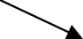

Used to connect process to each other, to sources of sinks; the arrow head indicates direction of data flow.
2. Process

Performs some transformation of input data to yield output data.

3. Source/Suit (external entity)

A source of system inputs or sinks of system output.

4. Data store

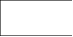
A logical file in which it is used to store table details.

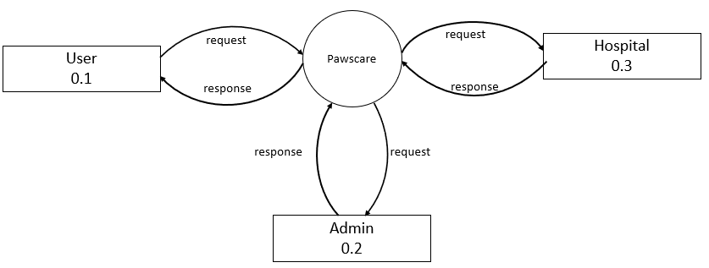
Level 0

Level 0.1

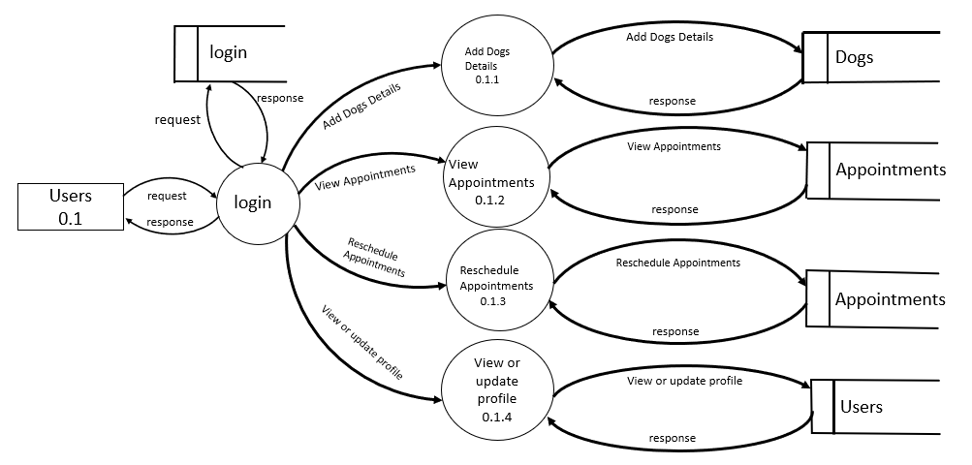
Level 0.2
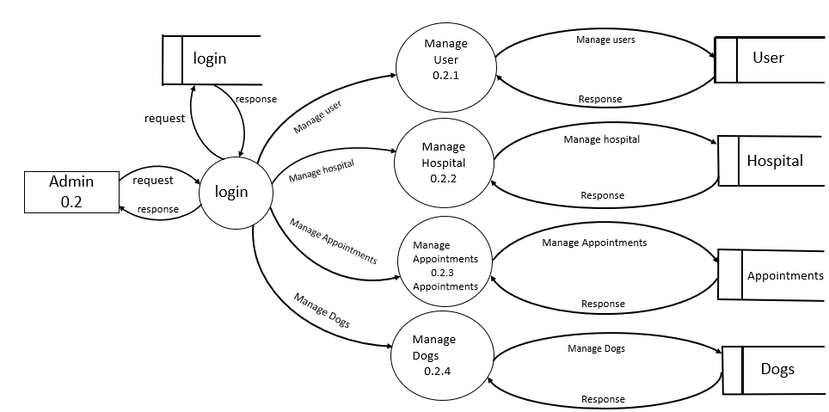

Level 0.3

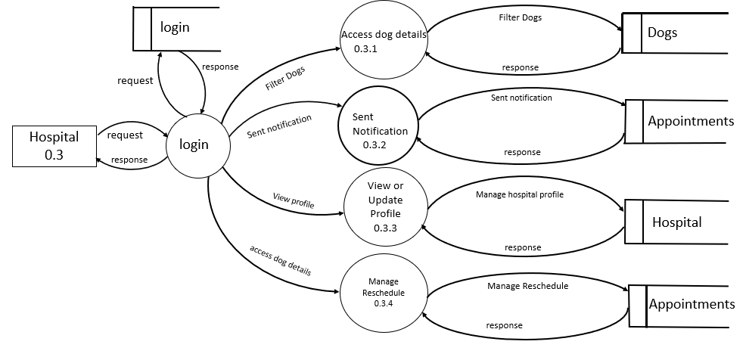

4.4 ER DIAGRAM
E-R Diagram is a logical representation of the data for an organization and uses 3 main constraints. That is, data entities, relationships and their associated attribute.

4.4.1 Entities:
An Entity is a fundamental thing of an organization about which data may be maintained. An entity has its own identity, which distinguishes it from each other entity. An entity type is the description of all entities to which a common definition and common relationships attributes applied.
4.4.2 Relationship:
A relationship is a reason for associating two entity types. These relationships are some-times called binary relationships. Because they involve two entity types. Some forms of data model allow more than two entity types to be associated.

4.4.3 Degree of Relationship:
The degree of a relationship is a number of entities that participate in that relationship. The 3 most common relationships in E-R models are:
1. Unary (Degree 1)
2. Binary (Degree 2)
3. Ternary (Degree 3)
Higher degree relationships are possible but they are rarely encountered in practice.
1. Unary Relationship
This is also called recursive relationship. It is a relationship between the instances of one entity type. An instance is a single occurrence of an entity type. There may be many instances of an entity type.
2. Binary Relationship
It is a relationship between instances of two entity types and is a most common type of relationship encountered in E-R diagram.
3. Ternary Relationship
It is a simultaneous relationship between instances of 3 entity types. Relationship may have provided the association of 3 entities. All the 3 entities are many to many participants. There may be one or many participants in a ternary relationship.
- Entities are represented by rectangles. An entity is an object or concept about which you want to store information.

- Actions are represented by diamond shapes, show how two entities share information in the database.

- Attributes are represented by ovals. A key attribute is the unique, distinguishing characteristic of the entity. For example, an employee's social security number might be the employee's key attribute

4.4.4 ER Diagram

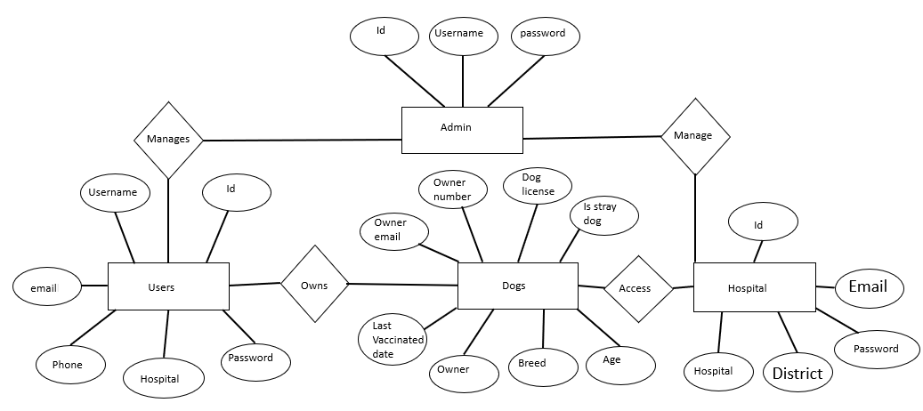

4.5 DATABASE DESIGN
Database design is the process of producing a detailed data model of database. This data model contains all the needed logical and physical design choices and physical storage parameters needed to generate a design in a data definition language, which an then be used to create a database. A fully attributed data model contains detailed attributes for each entity. The term database design can be used to describe many different parts of the design of an overall database system. Principally, and most correctly, it can be thought of as the logical design of the base data structures used to store the data. In the relational model these are the tables and views. In an object database the entities and relationships map directly to object classes and named relationships. However, the term database design could also be used to apply to the overall process of designing, not just the base data structures, but also the forms and queries used as part of the overall database application within the database management system (DBMS). Database Management is the key to effective handling of data within an organization and between different functional entities. The storage of all the data in a standardized and streamlined manner is important. The process of doing database design generally consists of a number of steps which will be carried out by the database designer. Usually, the designer must:
1. Determine the data to be stored in the database
2. Determine the relationships between the different data elements.
3. Superimpose a logical structure upon the data on the basis of these relationships. Benefits of a good database design include:
1. Efficient support for complex and interrelated business processes.
2. Lower cost of database ownership.
3. Consistent availability of data to support business operations and decision making.
4. Reduction in redundant data storage.
5. Increased productivity at work.
6. Avoidance of inconsistent data
4.5.1 Normalization:
- Normalization is the process of organizing the data in the database.
- Normalization divides the larger table into the smaller table and links them using relationship.
- The normal form is used to reduce redundancy from the database table.

Types of Normal Forms:
1. First Normal Form (INF):
The first normal form requires that a table satisfies the following conditions:
1. Rows are not ordered
2. Columns are not ordered
3. There is duplicated data
4. Row-and-column intersections always have a unique value
5. All columns are "regular" with no hidden values
2. Second Normal Form (2NF):
1.The table must be already in 1 NF and all non-key columns of the tables must depend on the PRIMARY KEY.
2 The partial dependencies are removed and placed in a separate table.
3. Third Normal Form (3NF):
The third normal form states that you should eliminate fields in a table that do not depend on the key.
1. Table is already in 2 NF
2. non-Primary key columns shouldn't depend on the other non-Primary key columns
3. There is no transitive functional dependency
4. Boyce-Codd normal form (BCNF):
It is an advance version of 3NF that's why it is also referred as 3.5NF. BCNF is stricter than 3NF. A table complies with BCNF if it is in 3NF and for every functional dependency X->Y, X should be the super key of the table.

4.6 TABLE DESIGN
4.6.1 Table Admin
FIELD NAME | DATA TYPE | SIZE | CONSTRAINTS | DESCRIPTION
ID | INT | 4 | PRIMARY KEY | ADMIN_ID
USERNAME | VARCHAR | 25 | NOT NULL | USERNAME
PASSWORD | VARCHAR | 25 | NOT NULL | PASSWORD

Table Description: To store admin details
4.6.2 Table Hospital
FIELD NAME | DATA TYPE | SIZE | CONSTRAINTS
ID | INT | 20 | PRIMARY KEY
HOSPITAL | VARCHAR | 20 | NOT NULL
DISTRICT | VARCHAR | 20 | NOT NULL
EMAIL | VARCHAR | 20 | NOT NULL
PASSWORD | VARCHAR | 20 | NOT NULL

Table Description: To store hospital details
4.6.3 Table Users
FIELD NAME | DATA TYPE | SIZE | CONSTRAINTS | DESCRIPTION
ID | INT | 20 | PRIMARY KEY | ID
USERNAME | VARCHAR | 200 | NOT NULL | USERNAME
EMAIL | VARCHAR | 200 | NOT NULL | EMAIL
PHONE | INT | 200 | NOT NULL | PHONE
HOSPITAL | VARCHAR | 200 | NOT NULL | HOSPITAL
PASSWORD | VARCHAR | 200 | NOT NULL | PASSWORD

Table Description: To store user details

4.6.4 Table Dog

FIELD NAME | DATA TYPE | SIZE | CONSTRAINTS
OWNER | VARCHAR | 200 | NOT NULL
OWNER_EMAIL | VARCHAR | 200 | NOT NULL
OWNER_NUMBER | INT | 200 | NOT NULL
DOG_LICENSE | INT | 200 | NOT NULL
AGE | INT | 200 | NOT NULL
BREED | VARCHAR | 200 | NOT NULL
IS STRAY DOG | VARCHAR | 200 | NOT NULL
LAST VACCINATED DATE | INT | 200 | NOT NULL

Table Description: To store user details
4.6.5 Table Appointments

ID | DATA TYPE | SIZE | CONSTRAINTS
LICENSE | INT |  | NOT NULL
USER | VARCHAR |  | NOT NULL
USER EMAIL | VARCHAR |  | NOT NULL
HOSPITAL | VARCHAR |  | NOT NULL
HOSPITAL EMAIL | VARCHAR |  | NOT NULL
DATE | INT |  | NOT NULL
TIME | INT |  | NOT NULL
STATUS | VARCHAR |  | NOT NULL
RESHEDULE | INT |  | NOT NULL
RESHEDULE DATE | INT |  | NOT NULL
RESHEDULE TIME | INT |  | NOT NULL

Table Description: To store user details

5. CODING AND TESTING

5.1 CODING STEPS
The coding step is a process that transforms design into a programming language. It translates a detail design representation of software into a programming language realization. The translation process continues when a compiler accepts source code as input and produces machine-dependent object code as output. Quality is an important goal during coding. The quality of source code can be improved by the use of structured coding techniques, good coding style and readable, consistent code format. During coding. Some coding standards are to be followed. This has two purposes; reducing the chance of making it easier for some time to modify the code later on. Coding phase affects both testing and maintenance profoundly.
The "PAWSCARE" uses Python as the programming language for coding. Python is an interpreted, interactive, object-oriented programming language. It incorporates modules, exceptions, dynamic typing. Very high-level dynamic data types, and classes. It supports multiple programming paradigms beyond object-oriented programming, such as procedural and functional programming Python combines remarkable power with very clear syntax. It has interfaces too many systems calls and libraries, as well as to various window systems, and is extensible in C or C++. It is also usable as an extension language for applications that need a programmable interface. Finally, Python is portable: it runs on many UNIX variants including Linux and macOS, and on Windows.
5.2. TEST PLANS
The purpose of system testing is to identify and correct errors in the candidate system. Testing is an important clement of the software quality assurance and represents the ultimate review of specification, design and coding. The increasing visibility of the software as a system element and the costs associated with a software failure are motivated forces for well planned, through testing.
The common view of testing held by users is that it is performed to prove that there are no errors in a program. However, as indicated earlier, this is virtually impossible, since analyst cannot prove that software is free and clear of errors. The tester, who may be the program fail. A successful test, then, is one that finds an error. Analysts know that an effective testing program does not guarantee system reliability. Therefore, reliability must be designed into the system.
Need of Testing
Testing is essential for:
▸ Existence of program defects of inadequacies is inferred.
▸ Verifies whether the software behaves as intended by its designer.

▸ Checks conformance with requirement specification/user needs.
▸ assesses the operational reliability of the system.
▸ Tests the performance of the system
▸ Reflect the frequency of actual user inputs.
▸ finds the fault, which caused the output anomaly.
Detects flaws and deficiencies in the requirements
Checks whether the software is operationally useful.
Exercises the program using data like the real data processed by the program.
The tan error is used to refer the difference between the actual output of the software and the correct output. Fault is a condition that causes the software to fail to perform its required function, Software reliability is defined as the required function
Software reliability is defined as the probability that the software will not undergo failure for a specified time under specified condition Failure is the inability of a system or a component to perform a required function according to its specification. Different levels of testing were employed for software to make an error free, fault free and reliable.

5.3. CLASSIFICATION OF TESTING
Basically, in software testing four type of testing methods are adopted
5.3.1. Security Testing
Security testing is the process to determine that an information system protects data and maintain functionality as intended. During security testing, the tester plays roles of the individual who desires to penetrate the system. The tester may attempt to acquire passwords through external clerical means, may attack the system with custom software designed to breakdown any defences that have been constructed, may overwhelm the system, thereby denying service to others, may cause system errors, hoping to find the key to system entry. Digital Fortress was tested for successful acceptance. User can enter to the website without register.
5.3.2. User Interface Testing
This tests the whole end to end scenario . This goes through all the mouse clicks and keyboard presses the user goes through to get an action done. If we extend the previous example this would be invoking the same action except that this time instead of using any test hooks it would be using the keyboard.

5.3.3. Performance Testing
Performance testing is designed to test the run time performance of software within the context of an integrated system. Performance testing occurs throughout all steps in the testing process. Even at the unit level, performance of individual module may be assessed as white box tests are conducted, it is not until all system elements are fully integrated that true performance of a system can be ascertained.
5.3.4. Test cases
A test case is a document that describes an input, action or event and an expected response, to determine if a feature of an application is working correctly. A test case should contain particulars such as test case identifier, test case name, test conditions, input data requirements steps, and expected results.

5.3.5 SAMPLE CODE
from django.shortcuts import render, redirect
from. models import User, Hospitals, Appointments, Dogs
from django.contrib import messages
from django.http import HttpResponse, HttpResponseRedirect
from .utils.auth import authenticate, is_authenticated, redirect_url
from .utils.date import datedifference
from .utils.dogslist import vaccinatedLists, unVaccinatedLists
from .utils.notification import send_notification
import random
from django.core.mail import send_mail
from django.conf import settings
from datetime import datetime
from dateutil import parser
def home(request):
return render(request, 'index.html')
def register(request):
if is_authenticated(request):
return redirect(redirect_url(request))
if request.method == 'POST':
username = request.POST['username']
email = request.POST['email']
phone = request.POST['phone']
hospital = request.POST['hospital']
password = request.POST['password']

if username != '' and email != '' and phone != '' and hospital != '' and password != '':
user = User.objects.filter(email=email).exists()
if user:
messages.error(request, "Email is already taken!!")
return redirect('register')
else:
request.session['email'] = email
request.session['username'] = username
request.session['phone'] = phone
request.session['hospital'] = hospital
request.session['password'] = password
otp = random.randint(1000, 9999)
request.session['otp'] = otp
email_from = settings.EMAIL_HOST_USER
recipient_list = [email]
send_mail("OTP VERIFICATION", 'Your otp to login PawsCare is '+ str(otp), email_from, recipient_list )
return redirect('otp-verify')
else:
messages.success(request, "Enter all fields!")
return redirect('register')
hospitals_list = Hospitals.objects.all()
return render(request, 'register.html', {'hospitals': hospitals_list})
def login(request):
if is_authenticated(request):

def otp_verification(request):
if request.method == 'POST':
otp = request.POST['otp']
if otp != '':
if int(otp) == int(request.session['otp']):
email = request.session['email']
username = request.session['username']
phone = request.session['phone']
hospital = request.session['hospital']
password = request.session['password']
user = User(username=username, email=email, phone=phone, hospital=hospital, password=password)
user.save()
if 'email' in request.session:
del request.session['email']
if 'username' in request.session:
del request.session['username']
if 'phone' in request.session:
del request.session['phone']
if 'hospital' in request.session:
if 'password' in request.session:

6. SYSTEM IMPLEMENTATION AND TESTING

6.1 SYSTEM SECURITY MEASURES
Security of a system is a crucial task. It is a process of ensuring confidentiality and integrity of the OS. A system is said to be secure if its resources are used and accessed as intended under all the circumstances, but no system can guarantee absolute security from several of the various malicious threats and unauthorized access. Security of a system can be threatened via two violations: Threat: A program which has the potential to cause serious damage to the system. Attack: An attempt to break security and make unauthorized use of an asset. Security violations affecting the system can be categorized as malicious and accidental. Malicious threats, as the name suggests are a kind of harmful computer code or web script designed to create system vulnerabilities leading to back doors and security breaches. Accidental Threats, on the other hand, are comparatively easier to be protected against. Example: Denial of Service Destock. Security is an important property of any software. Many applications are outsourced too where the application development lacks strong integration of software security. The growing need to address software security measures across development life cycle has been discussed here. Application Security can be seamlessly integrated in the SDLC by introducing specific steps or process within the development phases.
6.2. IMPLEMENTATION OF THE PROJECT
Implementation means putting the newly developed system into operation. It is the plisse in the project plan where the theoretical design is put into real test. This is the most crucial stage in the life cycle of a project. During implementation there has to be a strong interaction between the developers and the users. This is the phase where the new system is given a chance to prove its worth and to minimize the reluctance to change. The proposed system may be entirely new, replacing an existing one or may be modifications to the existing system to either case, proper implementation is necessary to generate a Confidence among users. If the users have achieved satisfaction with the new project, then the project can be termed as successful and then onwards its maintenance and other subsequent works can be started. The system goes for implementation only after passing through some rigorous testing, especially when it comes to operating systems and other system software.
The implementation phase of the software development is concerned with translating design specifications into source code. The user tests the developed system and changes are made according to their needs. Our system has been successfully implemented. Before implementation several tests to been conducted to ensure that no errors are encounter during the operation. The implementation phase ends with an evaluation of the system after placing it into operation for a period of time. Implementation is the third phase of the system process In order to achieve the

objectives and the expected performance the system has been developed in a highly interactive and user-friendly manner.
The implementations stage involves following tasks:
• Careful planning.
• Investigation of system and constraints.
• Design of methods to achieves the changeover.
• Training of the staff in the changeover phase.
6.3 MAINTENANCE
Maintenance involves the software industry captive, typing up system resources. It means restoring something to its original condition. Maintenance involves a wide range of activities including correcting. Coding, and design errors, updating documentation and test data, and upgrading user support. Maintenance was done after the success implementation. Maintenance is continued till the product is reengineered or deployed to another platform. Maintenance is also done based on fixing the problems reported, changing the interface with other software or hardware enhancing the software.
A Post-Implementation is conducted after completing a project. Its purpose is to evaluate whether project objectives were met, to determine how effectively the project was run, to learn lessons for the future, and to ensure that the organization gets the greatest possible benefit from the project. After a long project, the last thing many project teams want to do is relive the process and look for ways to improve. However, a forward-looking review can discover many tips and strategies for improvement. By conducting a thorough and timely PIR, you'll identify key lessons learned and you can then apply those lessons to the planning and management of future projects.

7.APPENDIX

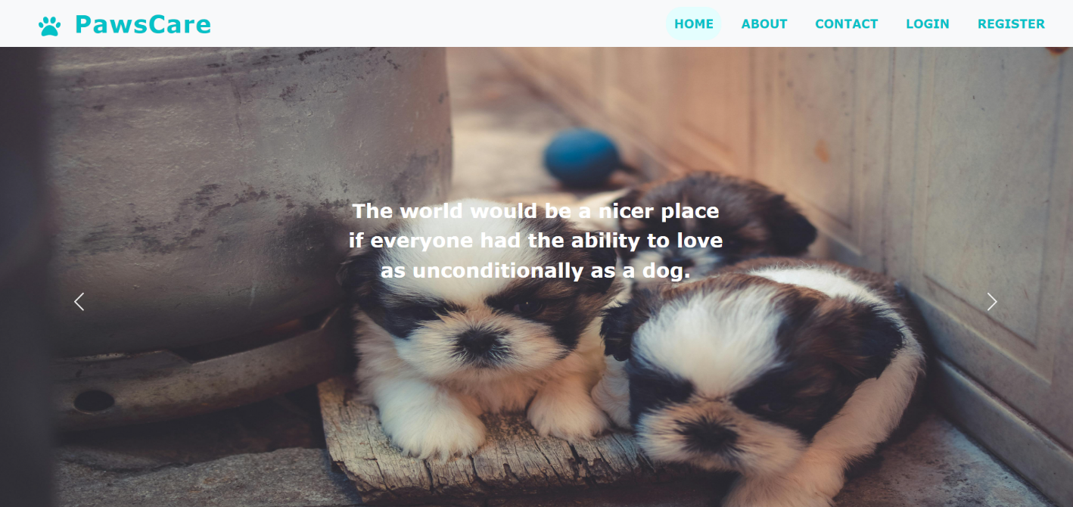
Figure 9.1 Home Page

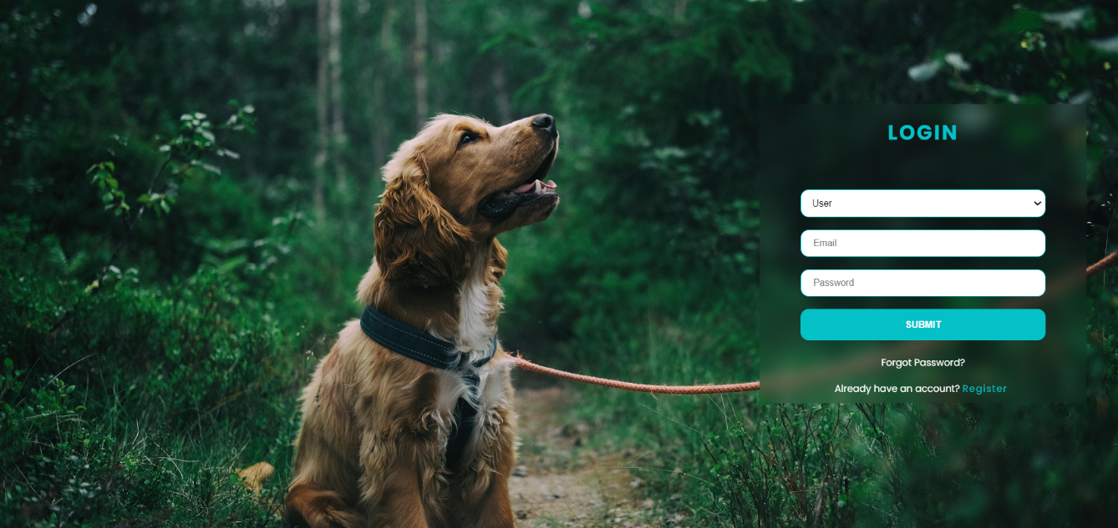

Figure 9.2 User login Page

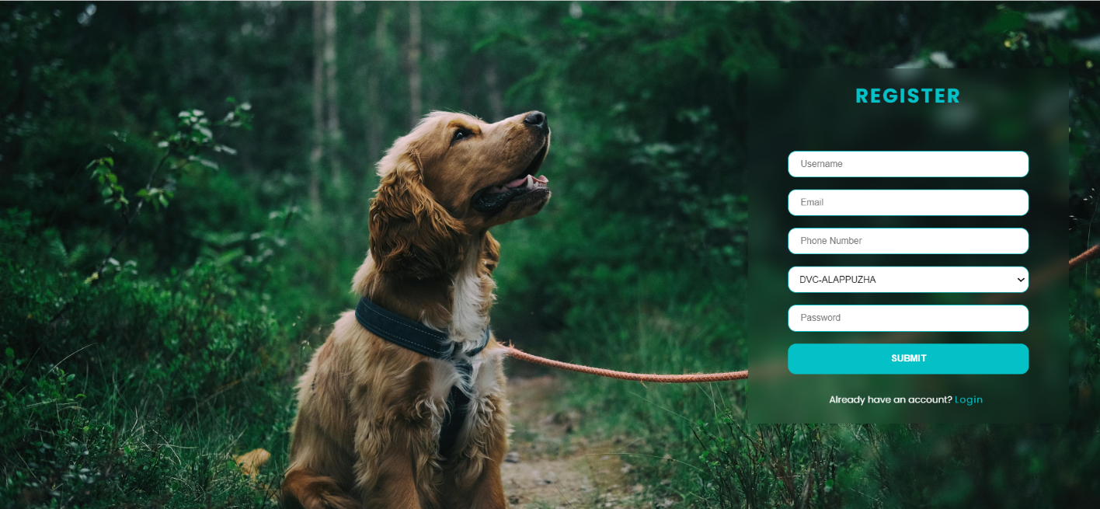
Figure 9.3 New User register Page

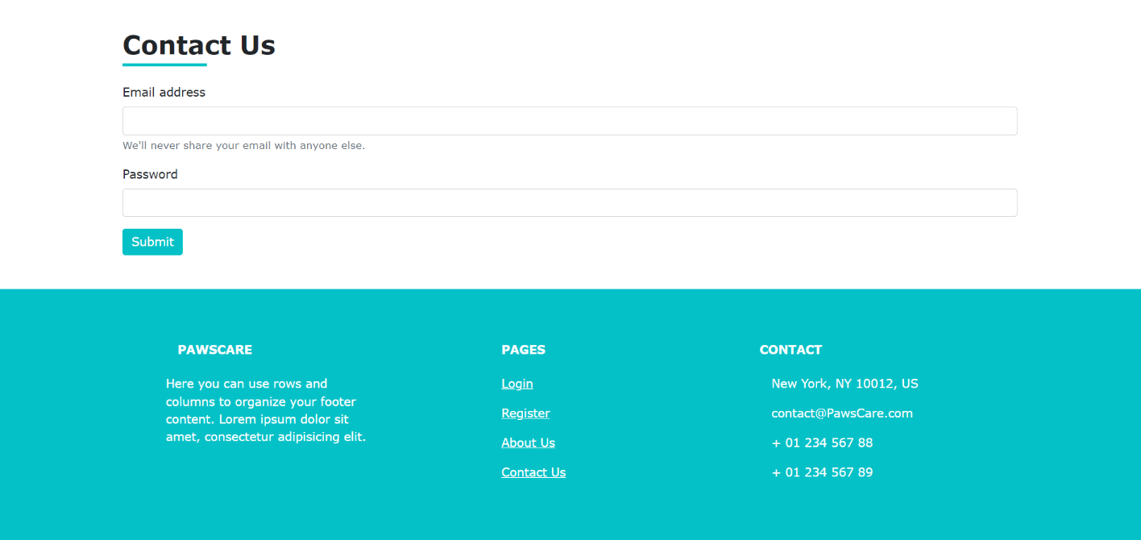

Figure 9.4 Contact Info Page

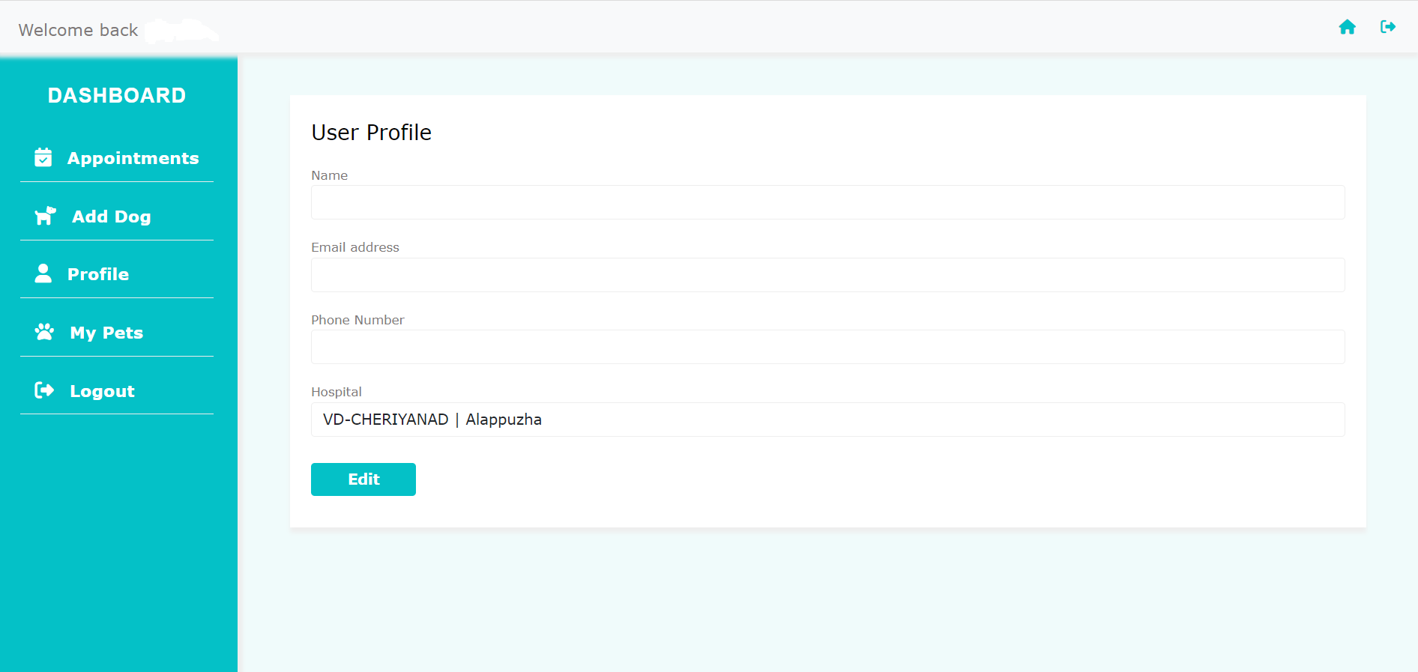

Figure 9.5 User Dash Board

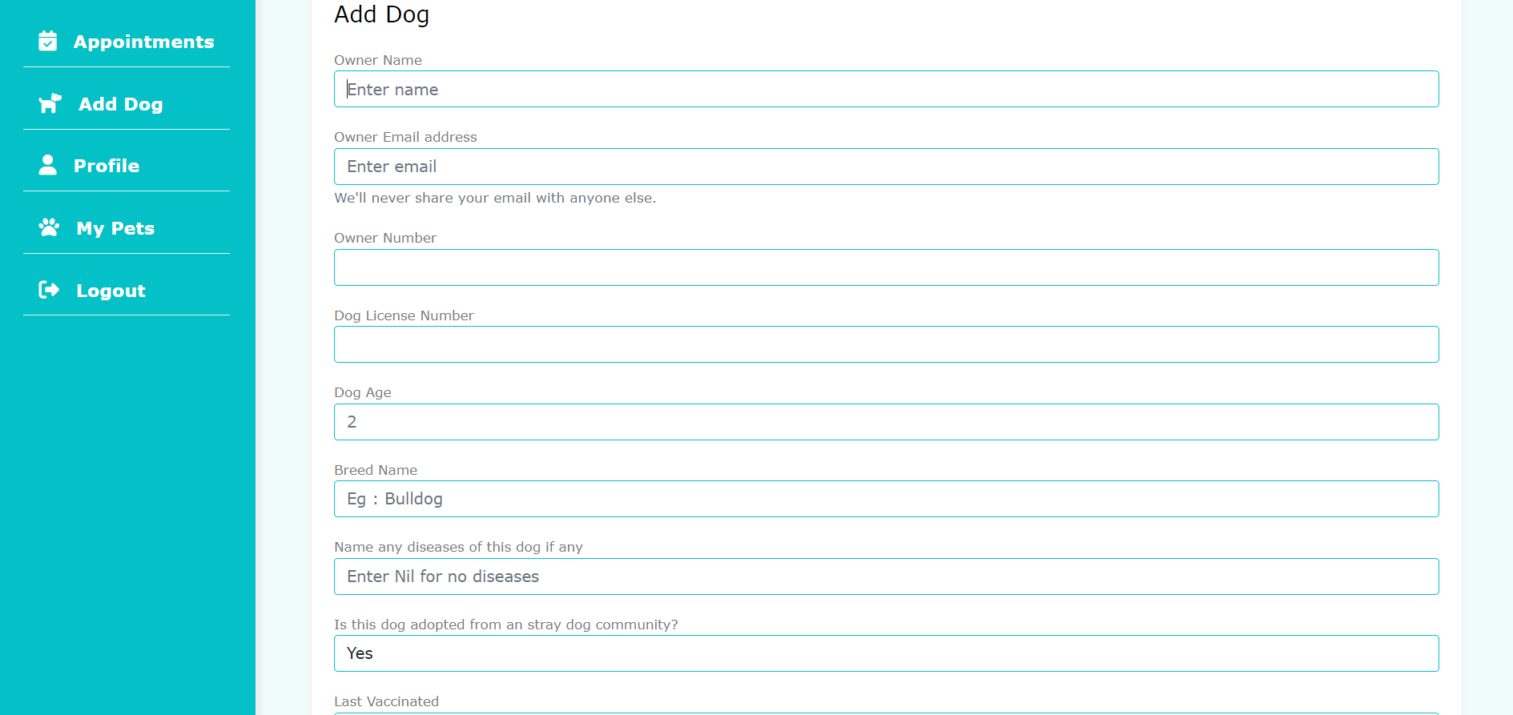

Figure 9.6 Adding Details

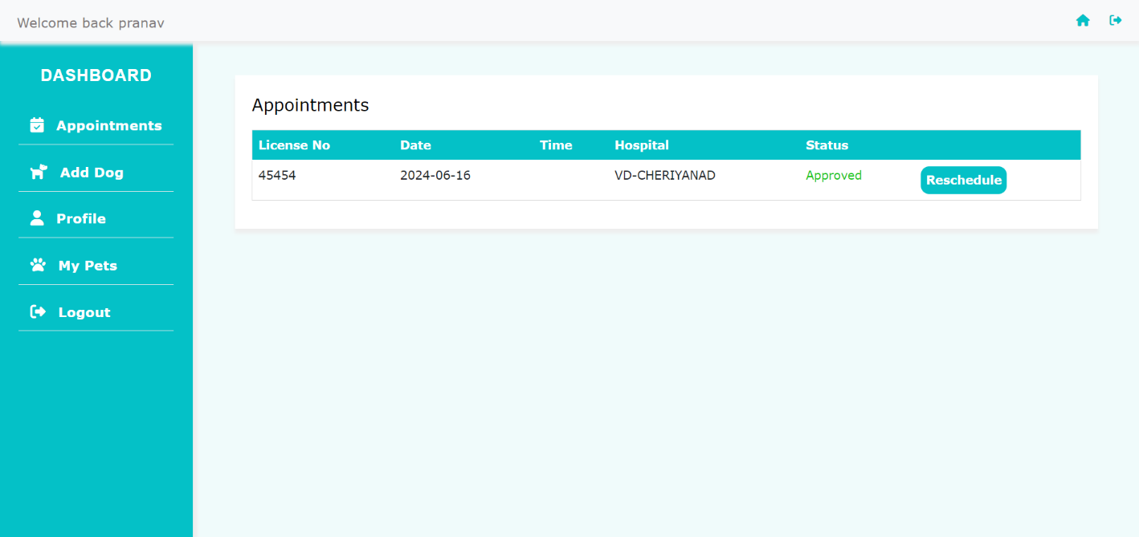

Figure 9.7 User Appointment Details

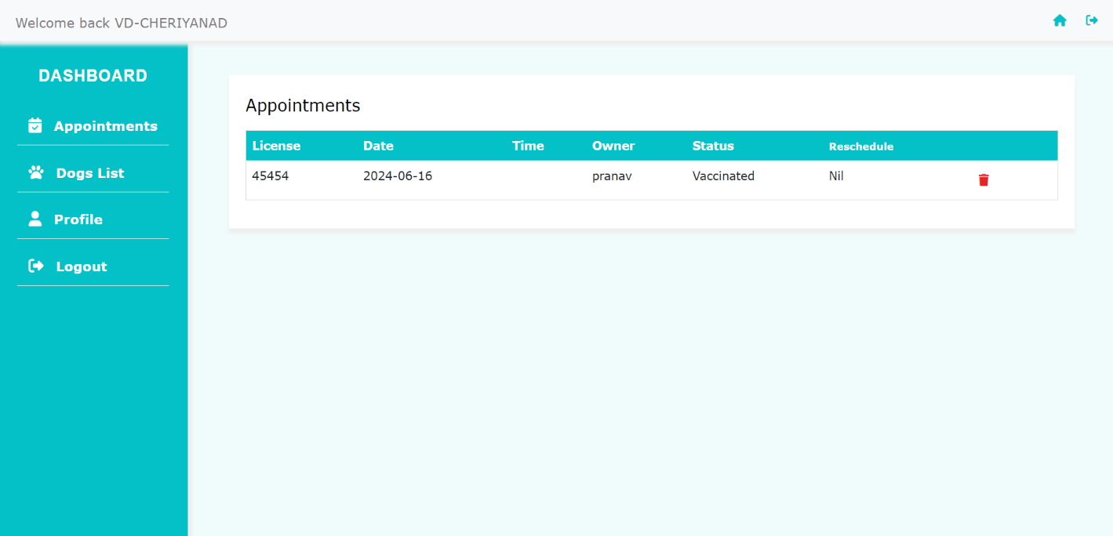

Figure 9.8 Hospital Dashboard

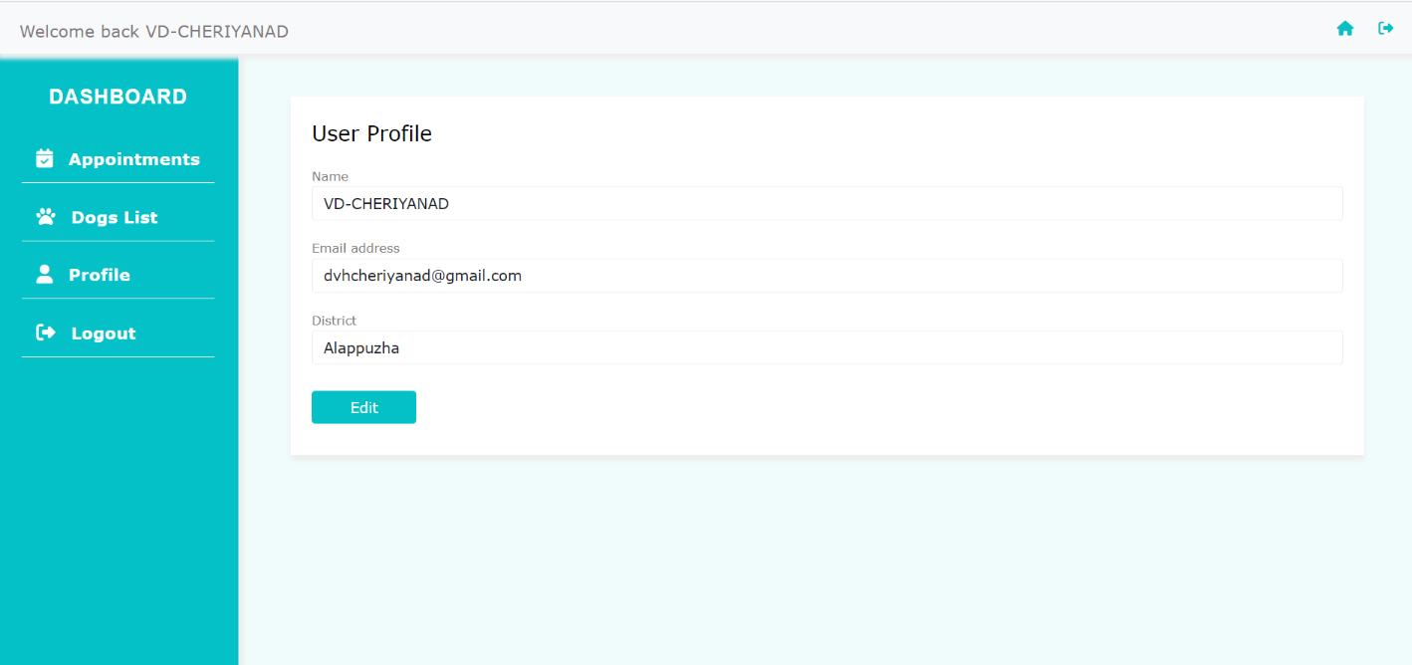

Figure 9.9 Hospital Details

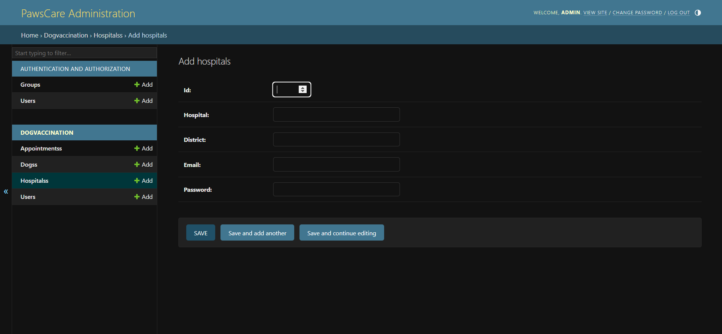

Figure 9.10 Add new fields
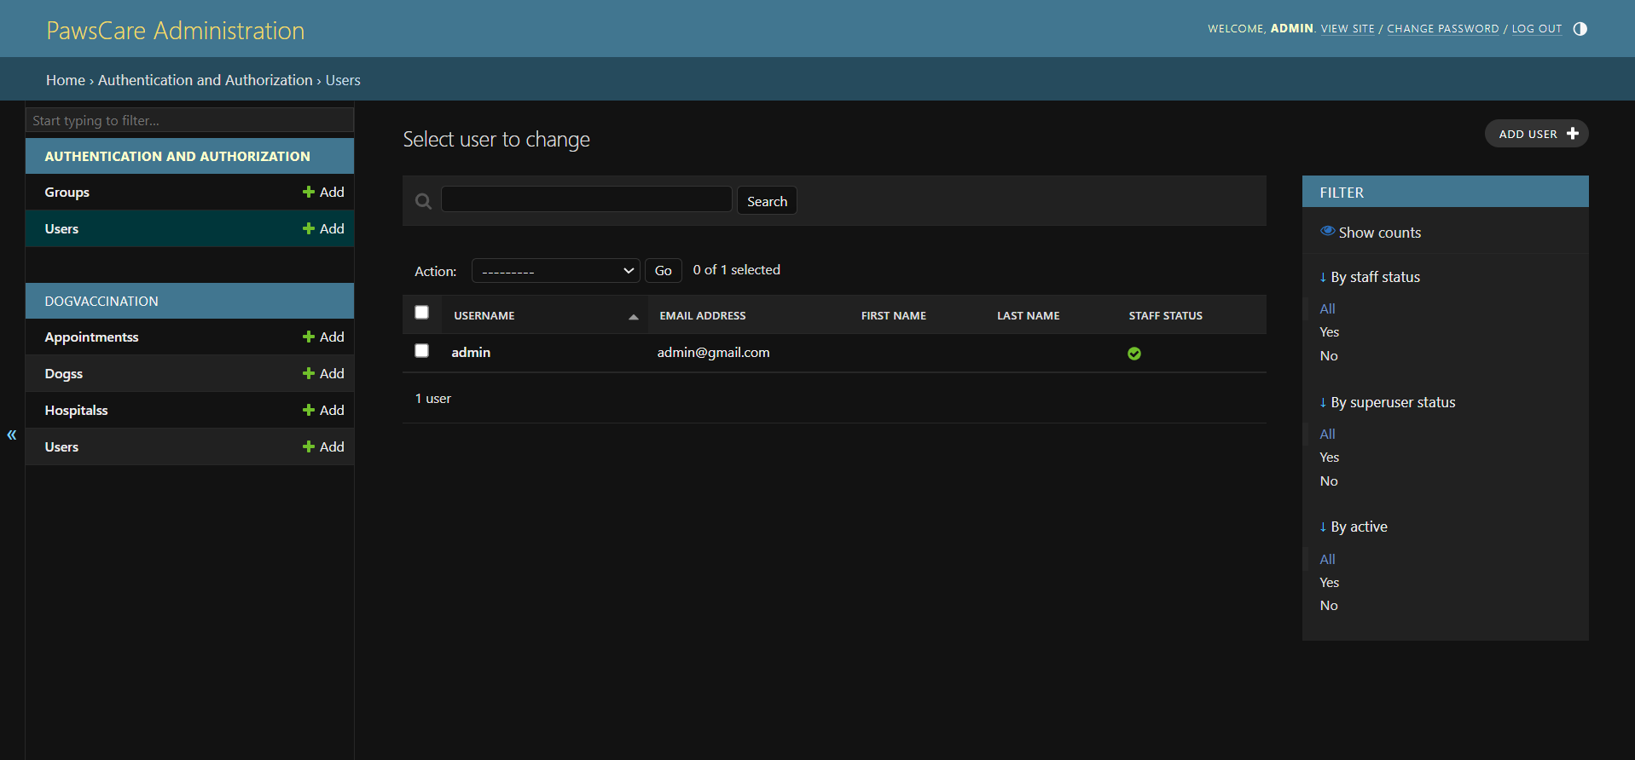
Figure 9.11 Admin

8. FUTURE ENHANCEMENT
At this stage we can only opt or get service under a selected district and the hospitals residing in the particular local body. So, in future we can bring whole state under this service. In future we can add other animals such as in different categories also be allowed to be served here.

9. CONCLUSION
The old manual system was suffering from a series of drawbacks. Since whole of the system was to be maintained with hands the process of keeping, maintaining and retrieving the information was very tedious and lengthy. The records were never used to be in a systematic order. There used to be lots of difficulties in associating any particular transaction with a particular context. If any information was to be found it was required to go through the different registers, documents there would never exist anything like report generation. There would always be unnecessary consumption of time while entering records and retrieving records. One more problem was that it was very difficult to find errors while entering the records. Once the records were entered it was very difficult to update these records. In present, work done in the electricity board is performed manually which is a great headache for the department. The reason behind it is that there is lot of information to be maintained and have to be kept in mind while running the business. For this reason, we have provided features Present system is partially automated (computerized), actually existing system is quite laborious as one has to enter same information at three different places.

10.BIBLIOGRAPHY

Text Books
1. Software Engineering- Somerville
2. Analysis and Design of Information System - James A.
3. MySQL4 - Ian Gilfillan
4. System Analysis and Design - Elias M Award
5. HTML 4.0 - E. Stephen Mack, Janan Platt

Web Reference
1.https://stackoverflow.com
2.https://wikipedia.org
3.https://python.org
4.https://alappuzha.nic.in/en/directory/district-veterinary-hospital/
5.https://kerala.data.gov.in/

